Maths Curriculum Overview
All our subjects are taught through our 6 core values, with which we aim to develop children who are:

Curious: inquisitive and inquiring
Aspirational: striving to achieve
Responsible: understanding of their involvement in their education and the wider world
Empathetic: welcoming of others’ opinions and valuing the feelings of others
Persevering: appreciative of the learning journey
Respectful: inclusive, local and global citizens

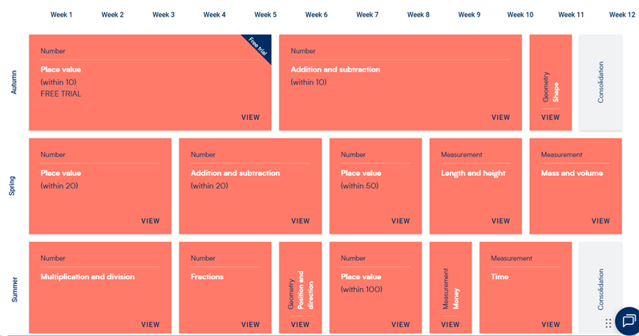



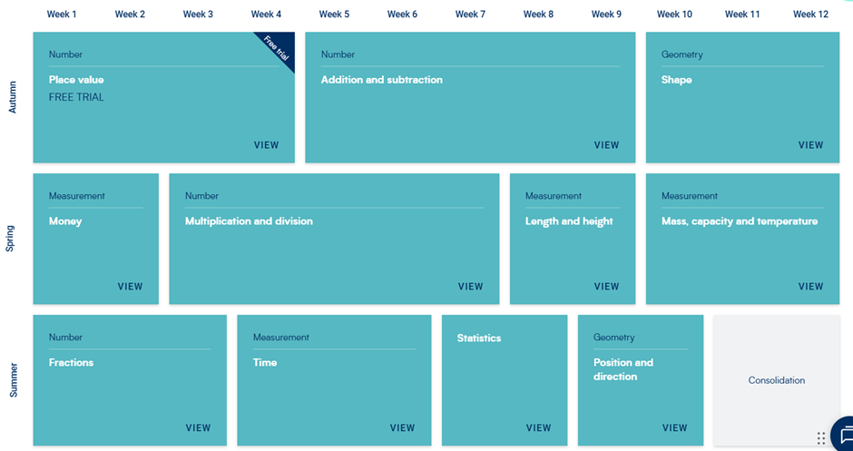


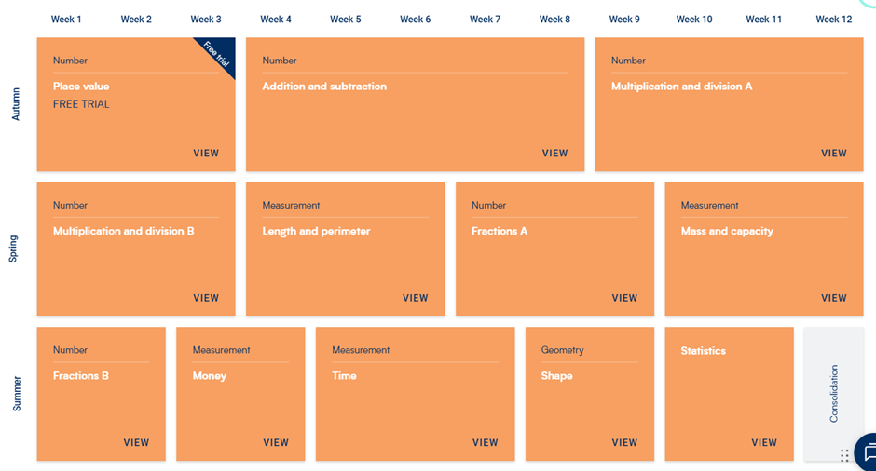

Year 4 – Yearly Overview
