Key Skills  Girton Glebe Primary School Curriculum Organiser  Year 3 (Lime Class) – Autumn Term 2 2020  Sequence dates and information from several historical periods on a timeline.  Ask well composed historical questions about aspects of everyday life in ancient periods.  Make deductions and draw conclusions about the reliability of a historical source or artefact.  Describe the hierarchy and different roles in past civilisations.  Devise or respond to historically valid questions about a significant historical figure and suggest or plan ways to answer them.  Explain the cause and effect of a significant historical event.  Describe the significance and impact of power struggles on Britain.  Make deductions and draw conclusions about the reliability of a historical source or artefact. | Emperors and Empires  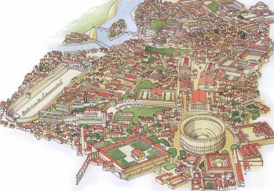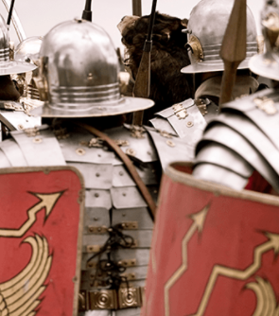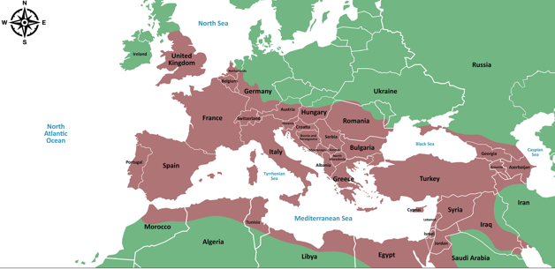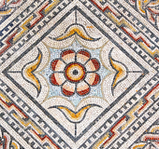 |  |  |  | Key Knowledge  Dates and knowledge can be sequenced on a timeline using AD or BC.  AD dates become larger the closer they get to the present day. BC dates become larger the further they get to the present day.  The year AD 1 marks the birth of Christ in the Gregorian calendar.  The Roman army conquered countries all around the Mediterranean Sea and so the Roman Empire grew to include many neighbouring lands. It was at its largest between AD 117 and AD 200.  Julius Caesar invaded Britain in 55 and 54 BC, but both invasions were unsuccessful. The Roman emperor, Claudius, successfully conquered Britain in AD 43.  Boudicca was the queen of the Celtic Iceni tribe who revolted against Roman rule in AD 60–61.  The emperor, Hadrian, ordered that a wall should be built along the frontier of Caledonia and Britannia in AD 122.  Roman Rule ended in Britain in AD 410
 | Key Vocabulary
 | Absolute power | aqueduct | consul | empire
 | hierarchy | hypocaust | Roman citizen | Hadrian
 | Boudicca | Britannia | Invasion | Timeline
English:  In English we will be basing our work on the Roman Diary: Journey of a Slave girl as well as writing news reports relating to our topic.  Opportunities for writing will include:  - Using conjunctions (when, if, because) to add subordinate clauses.  - Using conjunctions for time & cause - can link to subordination (using because and when, etc.).  - Using the present and past tenses correctly and consistently.  - Using present perfect form of verbs. Extend sentences by using range of conjunctions. Use conjunctions to express time.  - Learning to read and write independently in all areas of the curriculum.  - Identify the main point of each paragraph in a short text.  - Use and punctuate direct speech  - Using a dictionary to check the spelling and meaning of words as well as using a thesaurus to find synonyms and antonyms. | Science:  This half term we will be working on the topic : Animals , including humans.  During this topic we will cover the following skills:  • Identify that animals, including humans, need the right types and amount of nutrition, and that they cannot make their own food; they get nutrition from what they eat.  • Identify that humans and some animals have skeletons and muscles for support, protection and movement. |  |  |  | Maths:  This half term we shall be covering the following aspects of the maths curriculum:  Number – Addition and Subtraction:  - Add and subtract numbers with up to three s, using formal written methods of columnar addition and subtraction.  - Estimate the answer to a calculation and use inverse operations to check answers.  - Solve problems, including missing number problems, using number facts, place value, and more complex addition and subtraction.  Number – Multiplication and Division:  - Recall and use multiplication and division facts for the 2, 5 and 10 multiplication tables.  - Recall and use multiplication and division facts for the 3, 4 and 8 multiplication tables.
Computing:  This half term we will be  During this topic we will cover the following skills:  - Explain that the World Wide Web contains lots of web pages about different subjects that can be searched.  - Combine a range of text, images, animation and audio and video clips for given purposes.  - Explain the advantages and disadvantages of communicating electronically and strategies for preventing issues. | 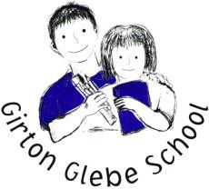 |  |  |  | R.E:  This half term we will be looking at: Church people – who are the ‘saints’  During this topic we will cover the following skills:  - Describe some Christian beliefs and practices and their importance to the national and regional saints.  - Recognise some of the similarities and differences between the lives of the national and regional saints.  - Make links between their own values and those of the saints.
Art/DT:  In Art/DT we will be During this topic we will cover the following skills:  - Compare artists, architects and designers and identify significant characteristics of the same style of artwork, structures and products through time.  - Use preliminary sketches in a sketchbook to communicate an idea or experiment with a technique  - Use and combine a range of visual elements in mosaic artwork  - Make suggestions for ways to adapt and improve a piece of artwork. | Class notices  PE: Sessions take place on Tuesday & Friday. PE Kit including sturdy trainers must be worn all day on PE days  PPA: Your child will be taught by Mrs Storer on Wednesday afternoons.  Reading: Please make sure that your child reads each day and record this is in the reading record.  Homework: Homework will be set on a Friday and is due the following Tuesday.  Spellings: Spellings will be given on a Friday and tested on the following Friday.  Muddy Maths: Muddy Maths will continue to take place on a Wednesday morning, please send your child to school with alternative footwear, a warm waterproof coat and if you have them then waterproof trousers. |  |  |  | PE:  In PE the children will be working on balls on the ground and a Haka dance (indoor and outdoor)  During this topic we will cover the following skills:  - Experience small-sided and modified competitive invasion games.  - Use and adapt simple tactics.  - Apply simple rules and conventions.  - Work in teams.  - Working in unison, mirroring, levels, speed, direction, control and jumping.  - We will work on turning gestures and action/reaction and formation.
PSHE:  In PSHE we will be thinking about my friends and family including anti-bullying.  We will cover the following skills:  - Be able to describe some of the qualities of a good friend.  - Understand and be able to cope with changes in friendship patterns.  - Be able to identify similarities and differences between themselves and their peers. | French:  In French the children will be using Rigalo to  Cover the following skills  :  - Learn new French vocabulary through conversation and interaction.  - Identify and use vocabulary related to colours, numbers, animals, family and everyday objects.

