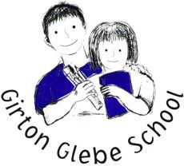
[Science] 2019-2020 Curriculum Overview

Class | Autumn 1 | Autumn 2 | Spring 1 | Spring 2 | Summer 1 | Summer 2
Ash | Our Bodies (healthy me) | Light and Dark | Growing (plants) | Journeys | Animals | Under the sea
Oak | Seasonal changes Autumn  Animals including humans  (year 1) | Seasonal changes Winter  Animals including humans  (year 1) | Everyday materials  (year 1) | Seasonal changes Spring  Inc Sci Week | Plants  (Year 1) | Seasonal changes Summer
Willow | Electricity | Rocks | Sound | Science Project  Inc Sci Week | Animals including humans | Living things and their habitat
Lime | Electricity | Rocks | Sound | Science Project  Inc Sci Week | Animals including humans | Living things and their habitat
Maple | Electricity | Evolution and inheritance | Earth and Space | Science Project  Inc Sci Week | Animals including humans | Living things and their habitat
Cherry | Electricity | Evolution and inheritance | Earth and Space | Science Project  Inc Sci Week | Animals including humans | Living things and their habitat
Birch | Electricity | Evolution and inheritance | Earth and Space | Science Project  Inc Sci Week | Animals including humans | Living things and their habitat

