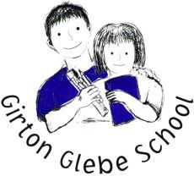
History and Geography 2019-2020 Curriculum Overview

Class | Autumn 1 | Autumn 2 | Spring 1 | Spring 2 | Summer 1 | Summer 2
Ash | Ourselves and Healthy Eating  - Handa’s Surprise  - Hungry Caterpillar | Light and Dark  - Can’t you sleep little bear  - Festivals/celebrations  - The Christmas story | Journeys  - Journey home from Grandpa’s | Growing Things  - The little red hen  - Jack and the beanstalk  - castles | Animals and Creatures  - Going on a bear hunt | Under the Sea  - Rainbow Fish  - Pirate Pete
Oak | Up our Street | Once Upon a Time | Around the World | London’s Burning | Beside the Seaside | Olympics
Willow | Weather and Climate | Romans | Rivers, Mountains and Coasts | Anglo Saxons/Vikings | Olympics | Ancient Egypt
Lime | Weather and Climate | Romans | Rivers, Mountains and Coasts | Anglo Saxons/Vikings | Olympics | Ancient Egypt
Maple | Romans | Ancient Egypt | WW2 (history focus) | WW2 (geography focus) | Olympics | Local Geography
Cherry | WW2 | WW2 | Anglo-Saxons/Vikings | Local Geography | Olympics (history focus) | Olympics (geography focus)
Birch | WW2 | WW2 | Anglo-Saxons/Vikings | Local Geography | Olympics (history focus) | Olympics (geography focus)

